PROGRAMMING LANGUAGE PROJECT

MANİSA CELAL BAYAR UNIVERSITY

FACULTY OF ENGINEERING AND NATURAL SCIENCE

DEPARTMENT OF COMPUTER ENGINEERING

PROJECT NAME : ULUKOD

SECOND EDUCATION YEAR 2024-2025

PREAPERED BY
SİNEM IŞIK / 230316019
MUHAMMET GÜLDEN / 210316086

LECTURER : DİDEM ABİDİN
RESEARCH ASSISTANT : UMUT DÖKMEN
LEXER
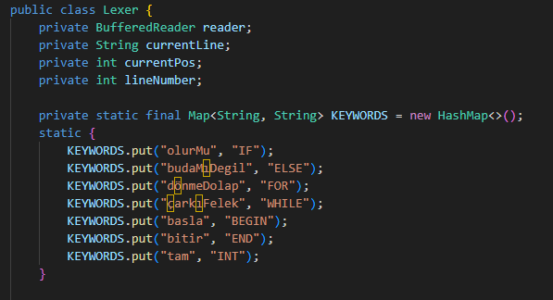
This structure allows the lexer to recognize Turkish keywords in the source code and convert them into standardized tokens (e.g., IF, WHILE) for the parser.

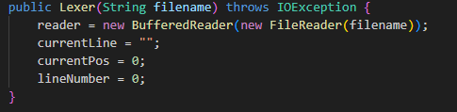
- File Reading Setup:
  - Initializes a BufferedReader to read the source code file specified by the filename parameter.
  - Example: If the file is ornek1.tk, it prepares to read this file line by line.
- Initializing Default Values:
  - currentLine: Stores the currently processed line (empty initially).
  - currentPos: Tracks the character position within the line (starts at 0).
  - lineNumber: Keeps count of the current line number (starts at 0).
- Error Handling:
  - Throws IOException if the file is not found or cannot be read.
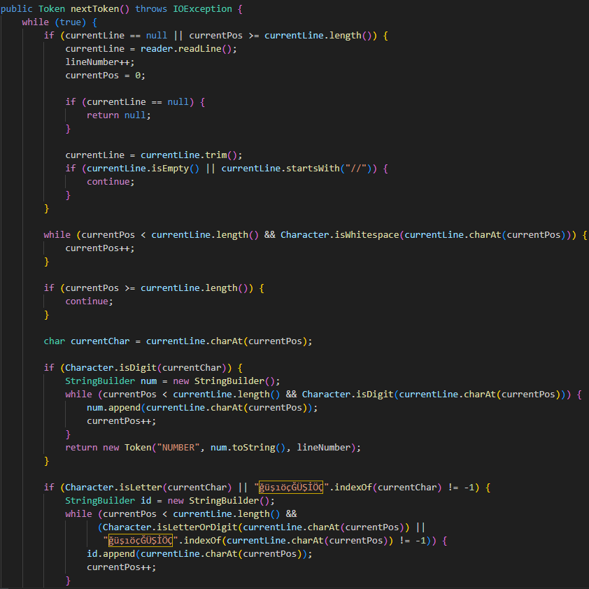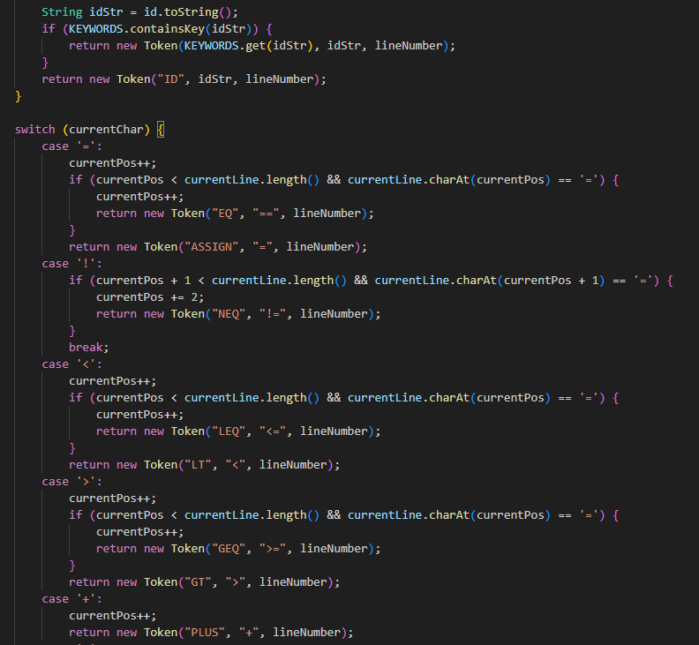
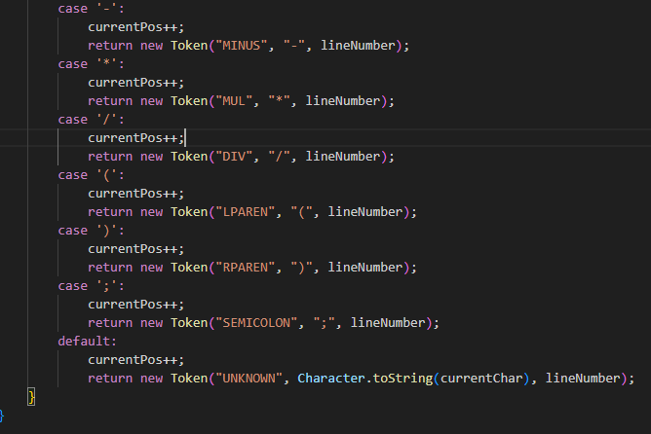
Key Features:
- Line Reading: Uses reader.readLine() to read the file
- Whitespace/Comment Handling: trim() and startsWith("//")
- Number Detection: Character.isDigit()
- Turkish Character Support: Handles ğüşıöçĞÜŞİÖÇ
- Multi-character Operators: Correctly handles ==, !=, <=, >=
- Standard Token Names: Uses ASSIGN, LEQ, GEQ
- Symbol Matching: Properly matches (, ), ;
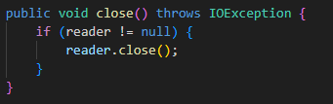
- Purpose:
  - Safely closes the BufferedReader used for reading the source file.
  - Prevents resource leaks by ensuring the reader is properly closed.
- Key Features:
  - Checks if reader exists (!= null) before attempting to close it.
  - Throws IOException if an error occurs during closing.
  - Follows Java's try-with-resources pattern best practices.
- Why the Fix?:
  - Original code had incorrect braces placement (} before reader.close()).
  - Empty if block would cause the close operation to execute unconditionally.
PARSER
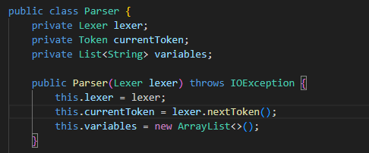
This constructor method initializes the Parser object by taking a Lexer instance as input. It fetches the first token produced by the lexical analyzer and initializes a list to store declared variables. This list is used later for variable declaration checks.

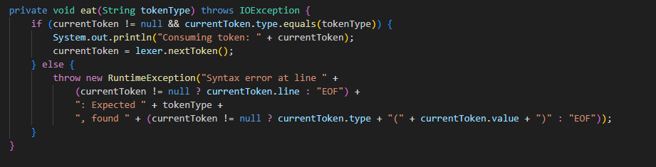
This method checks whether the current token matches the expected type. If it does, the token is consumed (the parser advances to the next token). Otherwise, a syntax error is thrown. This ensures the parsing process adheres to the expected grammatical structure.

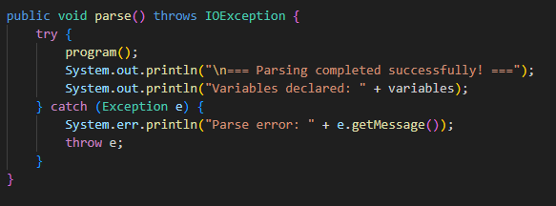
This is the top-level method that initiates the parsing of the entire program by calling program(). If any error occurs during parsing, an appropriate error message is displayed to the user.

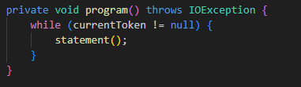
This method processes each statement in the source code sequentially by repeatedly calling the statement() method until no tokens are left.

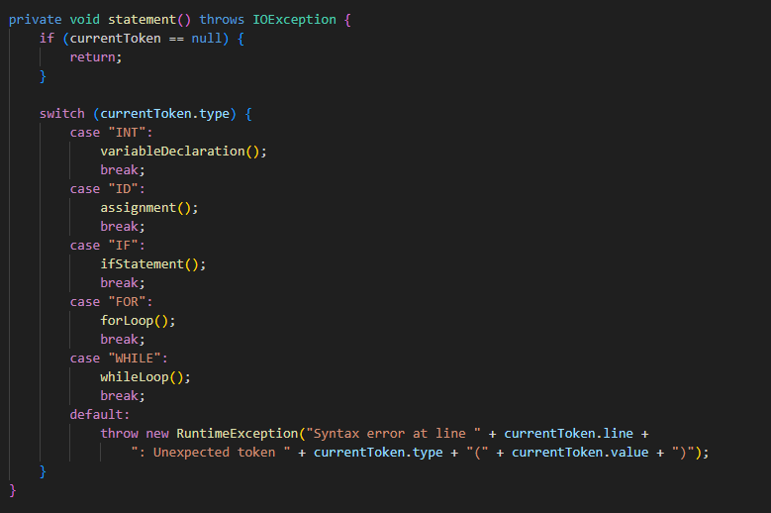
Determines the type of statement corresponding to the current token and dispatches it to the appropriate parsing method, such as for variable declarations, conditionals, loops, or assignments.

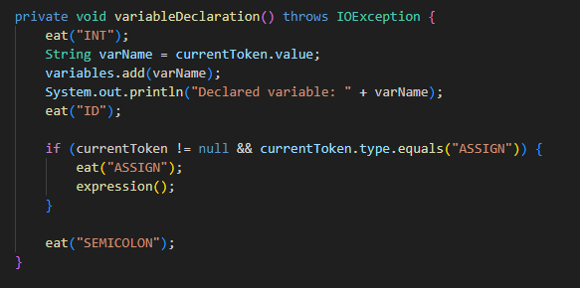
Parses variable declarations that begin with the INT keyword. The declared variable name is added to the variable list. If there is an assignment, the expression() method handles the value. The declaration ends with a semicolon.

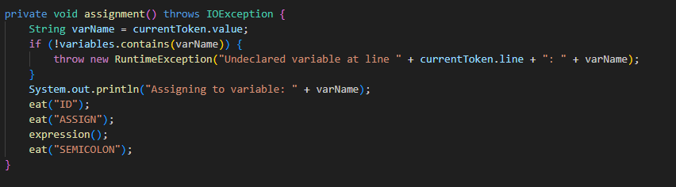
Handles assignment statements to previously declared variables. If the variable is undeclared, an error is thrown. The statement must end with a semicolon.

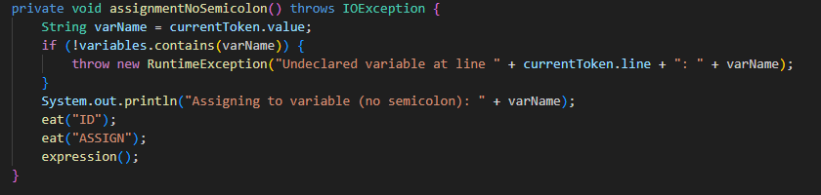
Used for assignment expressions that do not end with a semicolon, typically seen in the increment part of for loops.

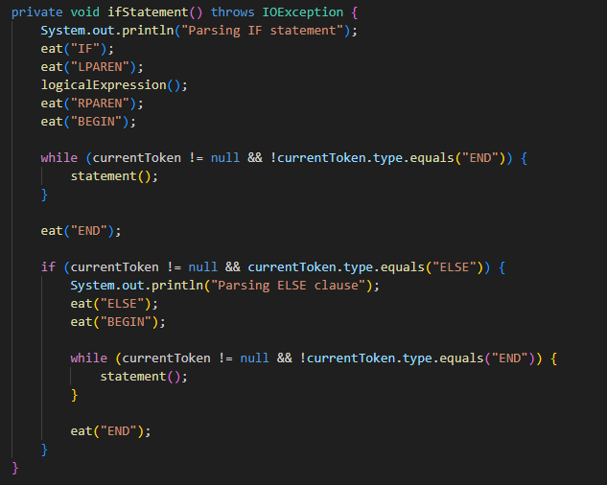
Parses if statements. Expects a logical condition within parentheses and processes statements between BEGIN and END blocks. An optional else block is also handled.

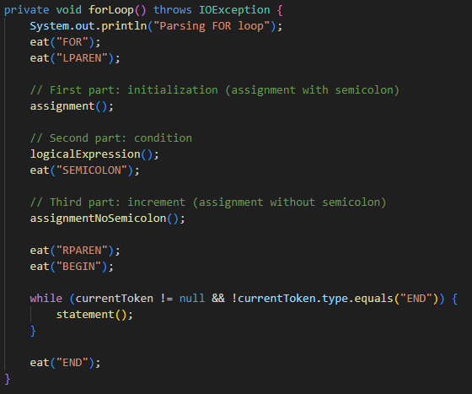
Parses for loop structures. It consists of three parts: initialization, condition, and increment. Then it processes the loop body enclosed between BEGIN and END.

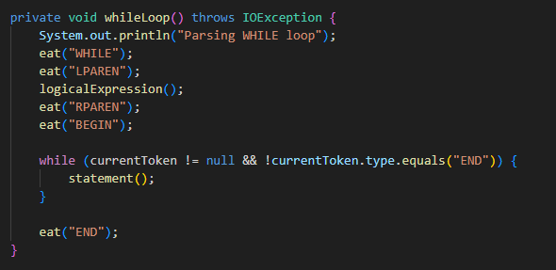
Parses a while loop. The condition is given in parentheses and the loop body is enclosed within BEGIN and END.

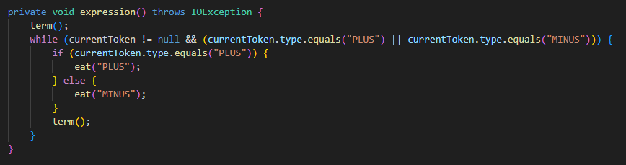
Parses arithmetic expressions involving addition and subtraction, relying on the term() method.

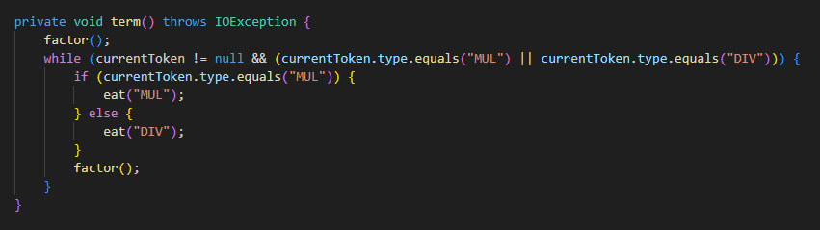
Parses multiplication and division operations. Each operand is handled by the factor() method.

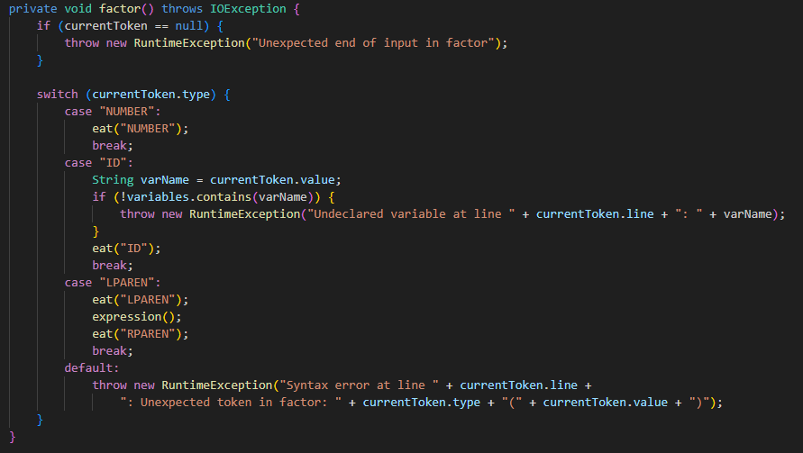
The smallest component of an expression. Handles numbers, declared variables, or parenthesized expressions.

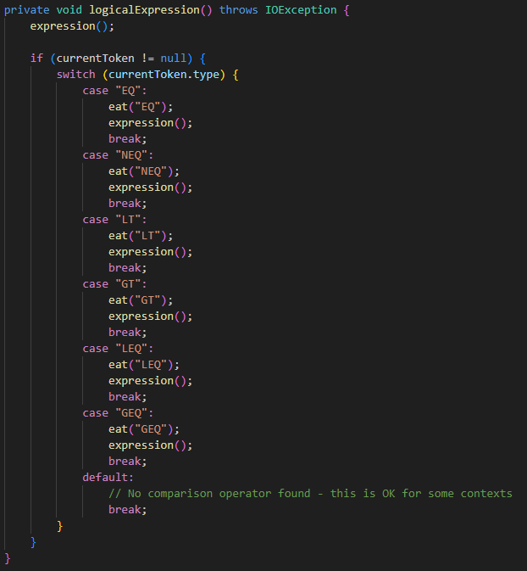
Parses logical expressions involving comparison operators like ==, !=, <, >, <=, and >=. Commonly used in control structures.

TOKEN
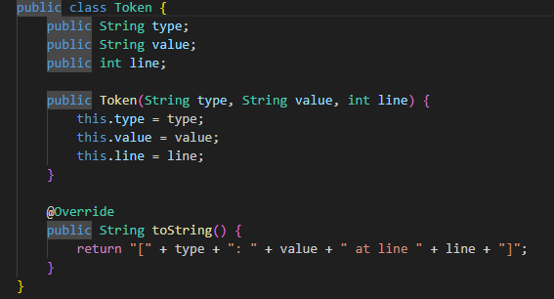
This class stores the type, value, and line of each symbol (token) read from a source (e.g., .tk file). It is later used by the Parser class for further processing.

State Diagrams
Program Structures:
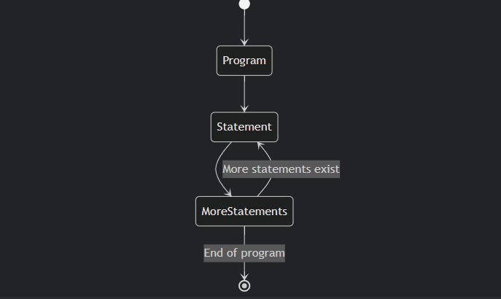

Statement Type:
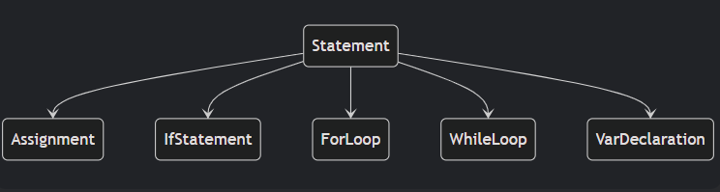

Assignment Statement:
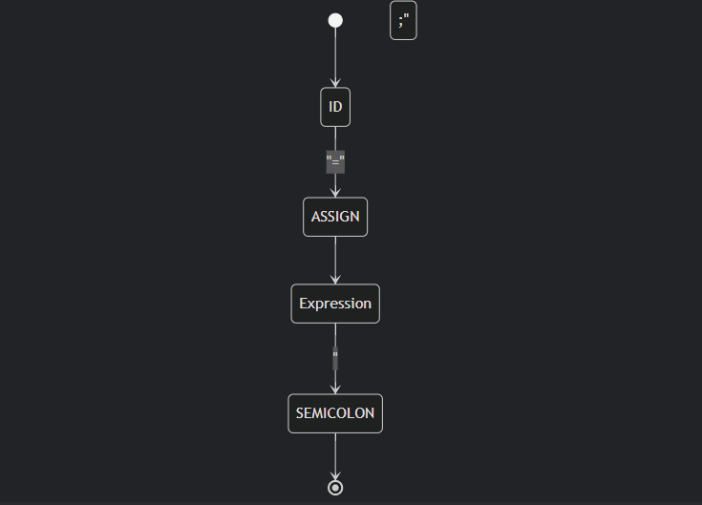

Variable Declaration:
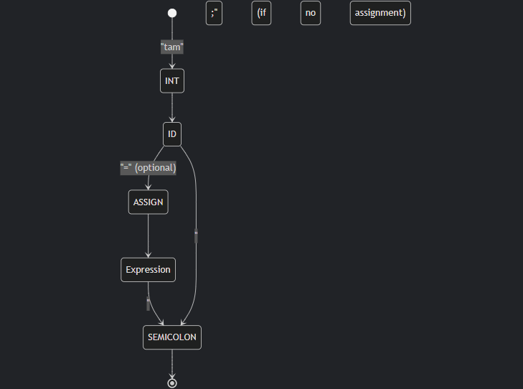
If Satement:
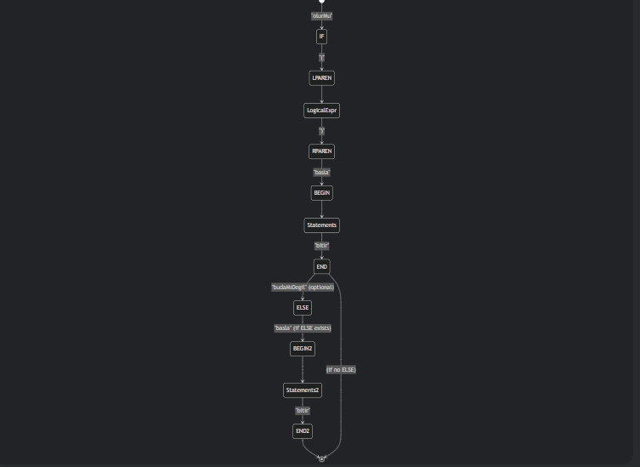

While Loop (ÇarkıFelek):
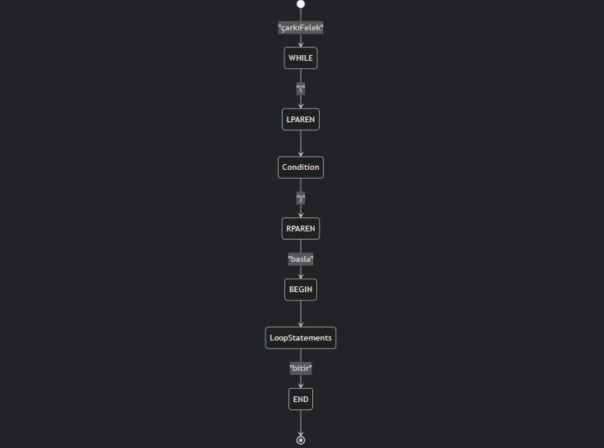
For Loop (Dönme Dolap):
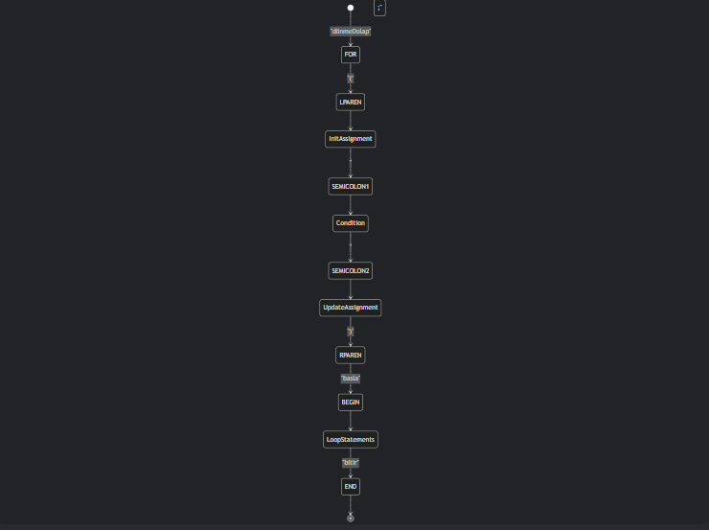
Expression Parsing:

Term Parsing:
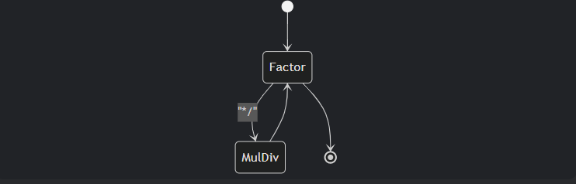
Factor Parsing:
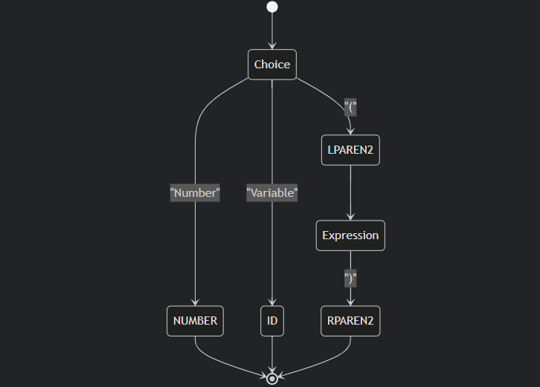

GRAMMER
program> ::= <deyimler>
<deyimler> ::= <deyim> | <deyim> <deyimler>
<deyim> ::= <atanma> | <kosul> | <dongu> | <degisken_tanimi>
<atanma> ::= <degisken> '=' <ifade> ';'
<kosul> ::= 'olurMu' '(' <mantiksal_ifade> ')' 'basla' <deyimler> 'bitir' |
'olurMu' '(' <mantiksal_ifade> ')' 'basla' <deyimler> 'bitir' 'budaMıDegil' 'basla' <deyimler> 'bitir'
<dongu> ::= 'dönmeDolap' '(' <atanma> ';' <mantiksal_ifade> ';' <atanma> ')' 'basla' <deyimler> 'bitir' |
'çarkıFelek' '(' <mantiksal_ifade> ')' 'basla' <deyimler> 'bitir'
<degisken_tanimi> ::= 'tam' <degisken> ';' | 'tam' <degisken> '=' <ifade> ';'
<ifade> ::= <terim> | <ifade> '+' <terim> | <ifade> '-' <terim>
<terim> ::= <faktor> | <terim> '*' <faktor> | <terim> '/' <faktor>
<faktor> ::= <sayi> | <degisken> | '(' <ifade> ')'
<mantiksal_ifade> ::= <ifade> '==' <ifade> | <ifade> '!=' <ifade> | <ifade> '<' <ifade> | <ifade> '>' <ifade>
<degisken> ::= [a-zA-ZğüşıöçĞÜŞİÖÇ][a-zA-ZğüşıöçĞÜŞİÖÇ0-9]*
<sayi> ::= [0-9]+

EXAMPLE1
tam sayi = 5;
sayi = sayi + 3 * (2 - 1);
olurMu (sayi == 8) basla
sayi = 0;
bitir

OUTPUT:
Declared variable: sayi
Assigning to variable: sayi
Parsing IF statement
Consuming token: [IF: olurMu at line 3]
Consuming token: [LPAREN: ( at line 3]
Consuming token: [ID: sayi at line 3]
Consuming token: [EQ: == at line 3]
Consuming token: [NUMBER: 8 at line 3]
Consuming token: [RPAREN: ) at line 3]
Consuming token: [BEGIN: basla at line 3]
Assigning to variable: sayi
Consuming token: [END: bitir at line 5]

EXAMPLE2
tam sayi = 5
sayi = sayi + 3
ERROR MESSAGE:
Syntax error at line 1: Expected SEMICOLON, found ID(sayi)
Tam sayi = 5 line is missing semicolon (;).
Grammar rule: <variable definition> ::= ‘tam’ <variable> ';'

EXAMPLE3
tam x = 1;
y = x + 2;
ERROR MESSAGE:
Undeclared variable at line 2: y
Variable y is used without being TAM defined.
The parser rejects variables that are not in the variables list.
EXAMPLE4
tam i = 0;
dönmeDolap (i = 0; i < 5; i = i + 1) basla
i = i + 1;
bitir
OUTPUT:
Declared variable: i
Parsing FOR loop
Consuming token: [FOR: dönmeDolap at line 2]
Consuming token: [LPAREN: ( at line 2]
Assigning to variable: i
Consuming token: [SEMICOLON: ; at line 2]
Consuming token: [ID: i at line 2]
Consuming token: [LT: < at line 2]
Consuming token: [NUMBER: 5 at line 2]
Consuming token: [SEMICOLON: ; at line 2]
Assigning to variable (no semicolon): i
Consuming token: [RPAREN: ) at line 2]
Consuming token: [BEGIN: basla at line 2]
Assigning to variable: i
Consuming token: [END: bitir at line 4]

